# C1- S4-PRACTICE

# Exercice 1

Q1 – Complete the **attributes type**s of Book and Read entities (5 points)

Q2 – Complete the **relation** between the Book and Reader entities (5 points)

|  |  |
| --- | --- |
| **Reader** | |
| ReaderID  Name  Class  Address | Numeric  String  String  String |

|  |  |
| --- | --- |
| **Book** | |
| BookID  Title  Publishment date  Language | Numeric  **String**  **Timeline**  **string** |

|  |  |  |
| --- | --- | --- |
| **Book borrow** | | |
| BookID  ReaderID | Numeric  One  Numeric |

many

Many

|  |  |
| --- | --- |
| **Reader** | |
| ReaderID  Name  Address  …………. | Numeric  String  String |

|  |  |
| --- | --- |
| **Book** | |
| BookID  Title  Language  ……………… | Numeric  String  String |

Q3 – We have created an **additional Associative table** to manage the previous relation between Book and Reader

* Complete the missing parts!

.

many

[Grab your reader’s attention with a great quote from the document or use this space to emphasize a key point. To place this text box anywhere on the page, just drag it.]

many

|  |  |
| --- | --- |
| **BookBorrow** | |
| BorrowID  Date borrow  Date return  ReaderID  BookID | Numeric  Timeline  Timeline  Numeric  Numeric |

many

many

# Exercice 2

Q1: complete the missing part of a model diagram below with PK as primary or FK foreign key.

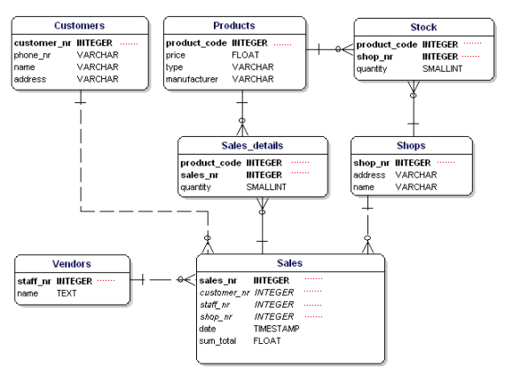

PK

FK

FK

PK

PK

??

??

??

??

??

PK

FK

??

??

PK

FK

??

??

PK

PK

PK

??

??

??

FK

FK

??

??

# Exercise 3

Q1: Complete the relation between each entity on the database relation model. Take for example the relation between **STUDENTS** and **PROJECTS.**

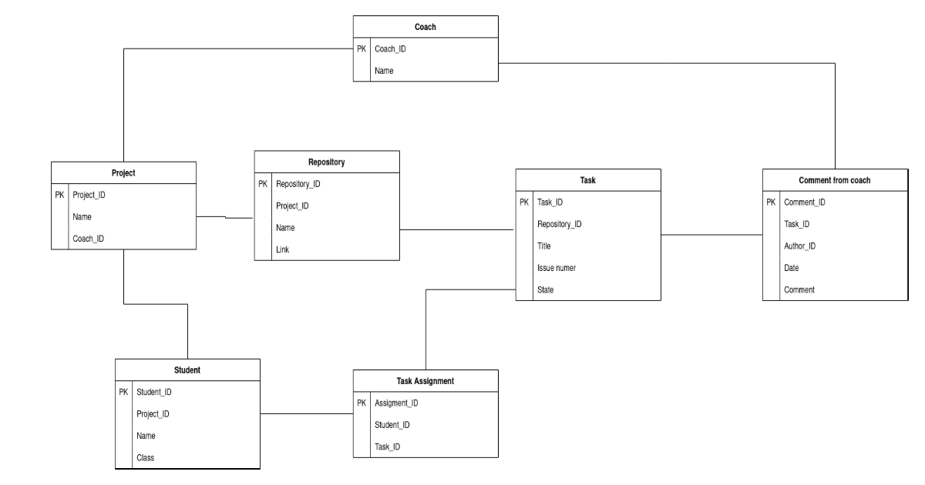

Many

Many

Many

Many

Many

Many

Many

Many

Many

Many

Many

Many

Many

Many

Many

Many

# Exercise 4

Google Classroom is the tool used to manage PNC classes, where the teacher can assign homework to the students of different classes.

**Q1**: Complete the attributes types in the following tables

|  |  |
| --- | --- |
| **User** | |
| user ID  email  password  name  role | **Numeric**  **string**  **string**  **string**  **string** |

|  |  |
| --- | --- |
| **Classroom** | |
| classroom ID  name  section  subject | **numeric**  **string**  **string**  **stirng** |

|  |  |
| --- | --- |
| **Assignment** | |
| assignment ID  title  description  deadline | **numeric**  **string**  **string**  **timeline** |

|  |  |
| --- | --- |
| **Comment** | |
| comment ID  content  user ID  assignment ID | **numeric**  **string**  **numeric**  **numeric** |

Here are some observations that can help us design the Google Classroom database:

* A user can create many classrooms as teacher
* A user can join many classrooms as student
* A classroom can have many teachers
* A classroom can have many students
* A teacher can post many assignments in a classroom, and the same assignment can be posted in several classrooms
* An assignment post can have many comments from students or teachers

**Q2**   **CLASSROOM** and **ASSIGNEMENT**

1. Type of relation: *one to one, one to many, many to many*?

Many to many.

1. Do you need to create an intersection table? Why?

No, I don’t because I don’t need add more.

1. Create the ERD representing to represent those 2 entities and their relation

|  |  |
| --- | --- |
| CLASSROOM | |
| ClassroomID | numeric |
| Name classroom | string |

|  |  |
| --- | --- |
| ASSIGNEMENT | |
| AssignementID | Numeric |
| Name assignment | string |
| Date | Timeline |

**Q3:**   **COMMENT** and **ASSIGNEMENT**

1. Type of relation: *one to one, one to many, many to many*

Answer: *Many to many*

1. Do you need to create an intersection table or not? Why?

Answer: No, I don’t because I don’t need to create more attribute.

1. Update the previous ERD to represent those 2 entities and their relation

|  |  |
| --- | --- |
| Assignment | |
| Assignment Id | Numeric |
| Assignment name | string |
| date | timeline |

|  |  |
| --- | --- |
| Comment | |
| Comment ID | Numeric |
| date | timeline |
| Name comment | string |

**Q4:**   **COMMENT** and **USER**

1. Type of relation: *one to one, one to many, many to many?*

Answer: *Many to many*

1. Do you need to create an intersection table or not? Why?

Answer: Yes, I do because I need to create date of user comment.

1. Update the previous ERD to represent those 2 entities and their relation

|  |  |
| --- | --- |
| user | |
| user ID | Numeric |
| User Name | string |

|  |  |
| --- | --- |
| Comments | |
| Comment ID | Numeric |
| date | timeline |
| Name comment | string |

|  |  |
| --- | --- |
| User comment | |
| user ID | Numeric |
| Comment ID | string |
| Date | Timeline |